

**TRIBHUVAN UNIVERSITY**

**FACULTY OF HUMAMITIES AND SOCIAL SCIENCE**

**A Project Proposal**

**On**

**Ecommerce**

**(ShopLunch)**

**Submitted to**

**Department of Computer Application**

**Morgan International College**

*In partial fulfillment of the requirements for Bachelor Degree of Computer Application*

**Submitted By:**

Bishal Aale Magar

**Under the Supervision of**

**Er. Shashiram Dahal**

**Table of Contents**

1. Introduction 1

2. Problem Statement 1

3. Objectives: 1

4. Methodology 2

4.1 Requirement Identification: 2

4.2 Study of Existing System: 2

4.3 Literature Review 2

4.4 Requirement Analysis 3

4.5 Feasibility Study 3

4.6 High Level Design System 4

5. Gantt Chart: 8

6. Expected Outcome 8

7. References 8

**List of Figures**

Figure 4.1: ER Diagram ............................................................................................... 4

Figure 4.2: Flowchart Diagram ............................................................................................ 5

Figure 5.1: Gantt Chart ........................................................................................................ 6

**List of Table**

Table 4.1: Requirement Identification ................................................................................. 2

# Introduction

With the growing emphasis on sustainability and budget-conscious shopping, second-hand marketplaces are becoming increasingly relevant. ShopLunch, originally developed as a streamlined e-commerce platform for small businesses and general product listings, is now evolving into a more dynamic solution. The updated version of ShopLunch aims to introduce a **bidding system for second-hand products**, allowing users to participate in live auctions and negotiate prices in real time.

This transformation responds to the demand for more flexible pricing, greater user engagement, and support for individuals and small sellers looking to recycle and resell pre-owned items. While the core principles of ShopLunch—user-friendly design, secure transactions, and accessible product discovery—remain intact, the platform will now foster a more interactive marketplace tailored to second-hand commerce. By integrating bidding features, the new ShopLunch empowers users with choice, fairness, and opportunity in every transaction.

# Problem Statement

In the current digital marketplace, there is a noticeable gap in platforms that effectively support **bidding systems for second-hand products**, especially in localized contexts. While many e-commerce solutions enable fixed-price listings, they often lack interactive features that empower buyers to negotiate prices or participate in real-time bidding.

Additionally, individuals looking to sell used items frequently face challenges such as **limited exposure**, **unreliable communication**, and **lack of trust** between buyers and sellers. Existing platforms may also fail to verify product authenticity or ensure transparent transactions, leading to user dissatisfaction and missed opportunities.

The previous version of ShopLunch provided a solid foundation for online shopping, but it did not accommodate the unique dynamics of second-hand product trading. To address these limitations, an enhanced system with a secure, user-friendly bidding mechanism is essential—one that promotes fair pricing, encourages sustainable consumption, and builds trust among users.

# Objectives:

• **To** develop and integrate a real-time bidding system for second-hand product listings on the ShopLunch platform.

• **To** provide a user-friendly interface that allows easy product uploads, bid tracking, and secure payment processing.

• **To** build a trusted marketplace by implementing user verification, product condition tagging, and transparent bidding history.

• **To** encourage sustainable commerce by enabling users to buy and sell pre-owned items in an organized and efficient manner.

# Methodology

## Requirement Identification:

**Table 4.1: Requirement Identification**

|  |  |
| --- | --- |
| **Category** | **Requirement** |
| Software | MERN stack |
| Hardware | Minimum 2GB RAM, Any low-end Windows/Linux laptop |
| User | Basic computer user |

## Study of Existing System:

In Nepal, the second-hand marketplace is still emerging in the digital space, with a few notable platforms catering to used goods. Websites like **HamroBazar** and **MeroOffer** have enabled classified-based listings where users can post second-hand items for sale. However, these platforms largely rely on static pricing models and lack integrated features like real-time bidding, automated auction timers, or secure in-platform transactions.

Social media platforms, especially **Facebook Marketplace**, are also popular for buying and selling used goods. However, these rely heavily on manual negotiation through chat and suffer from problems such as **lack of buyer protection**, **scattered product visibility**, and **unverified listings**. Additionally, none of these options offer structured auction mechanisms or support for dynamic pricing.

Despite the growing demand for second-hand goods—driven by economic factors, minimalism trends, and sustainability awareness—Nepal currently lacks a dedicated, secure, and interactive **bidding-based e-commerce platform**. This creates a significant opportunity for ShopLunch to introduce a hybrid model that combines the familiarity of traditional listings with the competitiveness and engagement of real-time auctions.

## Literature Review

The shift toward sustainable and budget-friendly shopping habits has led to a significant rise in second-hand e-commerce. ThredUp's annual report projects the global resale market to double by 2027, illustrating consumer preference for reuse over new purchases .Platforms incorporating **bidding systems**, such as eBay, show increased user engagement through time-bound auctions, which stimulate competition and drive higher perceived value [1].

In the context of Nepal, the e-commerce sector is expanding, but it remains largely focused on fixed-price listings. According to The Kathmandu Post, logistical limitations and the absence of advanced features such as bidding or secure transaction handling are still prevalent in local platforms [2]. This represents an opportunity for platforms likeShopLunch to innovate with auction mechanisms tailored to the Nepali market.

Moreover, trust is a critical component in second-hand online shopping. Studies have shown that platforms employing verified user systems and transparent bidding histories can significantly boost user confidence and reduce fraud [3] .

## Requirement Analysis

#### **i. Functional Requirements**

The proposed system shall include the following functional capabilities:

* **User Registration and Login:** The user must be able to create an account, log in, and manage their profile.
* **Product Listing:** Registered users (sellers) must be able to list second-hand products with details such as title, description, condition, starting bid, and images.
* **Bidding Mechanism:** Buyers must be able to place bids on listed products. The system should update the current highest bid in real time.
* **Auction Timer:** Each product listed for bidding must have a countdown timer that automatically ends the auction at a specified time.
* **Bid Notifications:** Users should receive real-time notifications when their bid is outbid or if they win an auction.
* **Order and Payment:** Once an auction ends, the system must notify the seller and buyer to proceed with payment and order fulfillment.
* **Admin Panel:** Admins must be able to monitor user activities, manage listings, and remove inappropriate content or users if needed.

#### **ii. Non-Functional Requirements**

The system shall also adhere to the following non-functional standards:

* **Security:** All sensitive data such as passwords and transactions must be encrypted. Only authenticated users should access bidding and listing features.
* **Performance:** The application should support concurrent bidding from multiple users without delays or crashes.
* **Scalability:** The system must be scalable to accommodate a growing number of users, product listings, and bids over time.
* **Usability:** The user interface should be intuitive and mobile-friendly, ensuring ease of use for both buyers and sellers.
* **Reliability:** The system must ensure data integrity during bidding and transactions, preventing loss or duplication of bids.
* **Maintainability:** The platform should be modular and maintainable for future upgrades, including support for new features like instant messaging or verified user badges.

## Feasibility Study

**TechnicalFeasibility:**  
The project can be built using popular technologies like React, Node.js, and MongoDB. These tools support real-time bidding and notifications, and the development team has the skills needed.

**EconomicFeasibility:**  
Since open-source tools are used, costs will be low. Hosting and domain fees are manageable. The platform can earn money through commissions and premium features, making it financially viable.

**OperationalFeasibility:**  
With growing internet use in Nepal, many people will benefit from a second-hand bidding platform. The system is easy to use for buyers and sellers. Admin controls will keep the platform safe and well-managed.

**ScheduleFeasibility:**  
The project is planned to be completed in about 4 to 6 months. This allows enough time for design, development, testing, and launch with room for unexpected delays.

## High Level Design System

1. **Working Mechanism of Proposed System**

Users register and log in to buy or sell second-hand products. Sellers list items with starting bids and auction times. Buyers place bids, which update in real time. Auctions end automatically when the timer runs out. Winners get notified to pay, and sellers prepare the order. Admins oversee the process to keep it smooth and secure.

1. **Description of Algorithms:**

• **Highest Bid Winning Algorithm:**  
Selects the highest bid placed before the auction ends as the winner.

• **Real-Time Bid Update Algorithm:**  
Keeps track of the highest bid by comparing new bids and immediately updates all users.

• **SHA-256 Hashing Algorithm:**  
Generates a secure hash of data to ensure it hasn’t been tampered with.

1. **ER Diagram**

**Figure 4.1: ERDiagram**

1. **Flowchart** 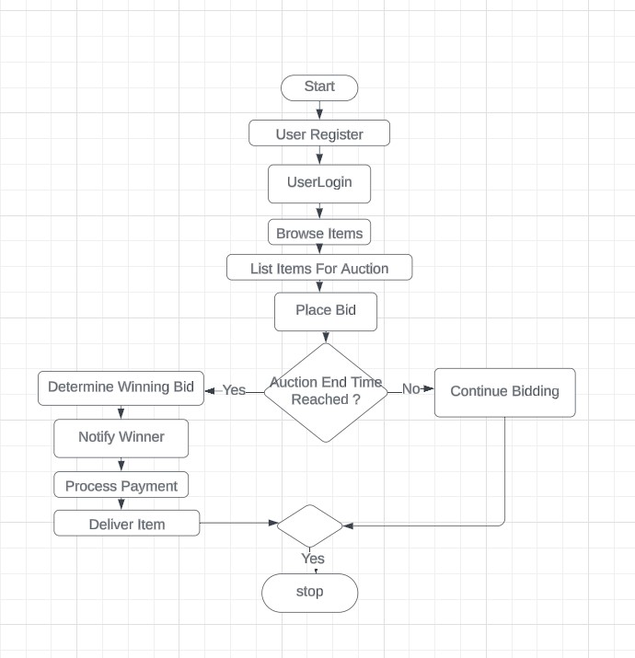

**Figure 4.2: Flowchart Diagram**

# Gantt Chart:

**Figure 5.1: Gantt Chart**

# Expected Outcome

* A fully functional bidding platform where users can list, browse, and bid on second-hand products seamlessly.
* Real-time updates of bids and auction status for an engaging user experience.
* Secure and transparent transactions with verified user accounts and data integrity checks.
* Increased user participation and trust in second-hand product auctions, promoting sustainable buying and selling.
* A scalable and maintainable system ready for future enhancements like instant messaging or premium features.

# References

|  |  |
| --- | --- |
| [1] | A. Kalwar and M. Kamal, "A Study on Consumer Behavior in Online Auctions," 2015. |
| [2] | k. rai, "E-commerce rises rapidly but logistics still lag,," *The Kathmandu Post,* 2022. |
| [3] | A. A. H. a. D. E. T. T. Sabou, "Building Trust in Online Marketplaces," 2022. |